PROJECT TTLE

By

2411EC010052 SHAYILI SHUSHANK
2411EC010054 VALLABHAREDDY SIVA NAGA SRI
2411EC010055 SRINIDHI JENA

Under the esteemed guidance of
Dr. K. Muralidhar Goud
Associate professor
Department of ECE


Department of Electronics and Communication Engineering (ECE)
II YEAR- I SEM
Malla Reddy University
2024-2028



Department of Electronics and Communication Engineering (ECE)

CERTIFICATE
This is to certify that this is the project report entitled “PROJECT TITLE” submitted by B. SAI MANI DEVENDAR REDDY (2111CS040089), M. POOJITH MOHAN VAMSI (2111CS040071), B. NITHIN REDDY (2111CS040064) and J. NITHIN RAJ (2111CS040065) B. Tech II year II semester, Department of Electronics and Communication Engineering (ECE), during the year 2025-26. The results embodied in this report have not been submitted to any other university or institute for the award of any degree or diploma.

Internal Guide Dean & Head of the department
Dr. K. Muralidhar Goud Dr. G. Anand Kumar
Associate Professor CSE (Cyber Security & IoT), ECE
ECE

DECLARATION

We hereby declare that the project report “PROJECT TITLE”, has been carried out by us and this work has been submitted to the Department of Electronics and Communication Engineering (ECE), Malla Reddy University, Hyderabad. We further declare that this project work has not been submitted in full or part for the award of any other degree in any other educational institutions.

Place:

SHAYILI SHUSHANK 2411EC010052

SIVA NAGA SRI 2411EC010054

SRINIDHI JENA 2411EC010055

ACKNOWLEDGEMENT

We extend our sincere gratitude to all those who have contributed to the completion of this project report. Firstly, we would like to extend our gratitude to Dr. V. S. K. Reddy, Vice-Chancellor, for his visionary leadership and unwavering commitment to academic excellence.
We are also grateful to Dr. G. Anand Kumar, Dean and Head of the Department ECE, Cyber Security & IOT, for providing us with the necessary resources and facilities to carry out this project.
We would like to thank Dr. S. Srinivasa Rao, Dean Academics and Planning, School of Engineering, for his encouragement and support throughout my academic pursuit.
We would also like to express our deepest appreciation to our project guide Mrs. B. Swetha, Assistant Professor, Department of ECE whose invaluable guidance, insightful feedback, and unwavering support have been instrumental throughout the course of this project for successful outcomes.
We extend our gratitude to our PRC – convenor, Dr. G. Latha, for giving valuable inputs and timely guidelines to improve the quality of our project through a critical review process. We thank our project coordinator, Dr. V. Gopi Tilak, for his timely support.
We are deeply indebted to all of them for their support, encouragement, and guidance, without which this project would not have been possible.
- Shushank 2411EC010052
V. siva Naga sri 2411EC010054
J. Srinidhi 2411EC010055

ABSTRACT

Smart Cradle Monitoring System:
Problem it Solves: It addresses the difficulty parents face in constantly monitoring their babies' safety, health, and comfort in today's busy world.
Core Technology: It's a Smart Cradle Monitoring System that uses sensors and the Internet of Things (IoT) to automate and monitor baby care in real-time.
How it Works:
* Sensing: It uses a set of sensors to detect the baby's vital signs and environment, including motion, crying, temperature, and humidity.
* Automation: A microcontroller processes these signals and performs responsive actions to comfort the baby, such as gently shaking the cradle or playing a lullaby.
*Parental Monitoring: It sends a live alert to parents' smartphones through an app, allowing them to remotely view and monitor their child.

INDEX
CONTENTS | Page No
Chapter-1 Introduction | 1-5
1.1 Background of the problem  1.2 Motivation and need for the project  1.3 Problem statement  1.4 Objectives of the project  1.5 Scope of the project  1.6 Organization of the report | 1  2-5  5-6  6-7  7  8
Chapter-2 Literature and Existing system | 9-16
2.1 Overview of previous works  2.2 Limitations in existing systems  2.3 Research gap identified  2.4 Summary | 9-10  10-11  11-12  12-13
Chapter-3 Proposed System / Methodology | 14-20
3.1 System architecture / block diagram  3.2 Working principle  3.3 Detailed explanation of each block/component  3.4 Flowchart or algorithm steps  3.5 Hardware and software requirements | 14  15-17  18-19  19-20  21-22
Chapter-4 Design and Implementation | 23-35
4.1 Circuit diagrams / PCB layouts / Simulation diagrams  4.2 Hardware design (microcontroller, sensors, modules used, etc.)  4.3 Software design (code flow, logic explanation)  4.4 Communication protocols used  4.5 System integration details | 23-24  25-27  28-30  31-32  33-35
Chapter-5 Results and Discussion | 36-45
5.1 Experimental setup  5.2 Output results (simulation screenshots, measured readings, waveforms)  5.3 Performance analysis | 36-37  38-43  44-45
Chapter-6 Conclusion and Future Scope | 46-47
6.1 Conclusion  6.2 Future scope | 46  47
References | 48-50

List of Figures | PageNo
3.1 Architectural Diagram | 21
3.2 Class Diagram | 22
3.3 Usecase Diagram | 23
3.4 Sequence Diagram | 24
3.5 Activity Diagram  List of Screenshots | 25
5.1 UserInterfaceto Register. | 48
5.2 UserInterfacetoselectaSecurityQuestion. | 49
5.3 UserInterfaceforHomePage | 49
5.4 LoginandPasswordRecoveryInterface | 50
5.5 PasswordRecoveryProcess | 50
5.6 Passwordsentthroughemail | 51
5.7 HomePage | 51
5.8 InvalidCredentialsPopup | 52
5.9 InvalidSecurityAnswer Popup | 52
5.10 InvalidOTPPopup | 53

CHAPTER - 1 INTRODUCTION

In the digital landscape, securing user data is vital, particularly on platforms like free onlinebook-readingwebsiteswherepersonalinformationisstored.Thisprojectfocuses on enhancing the security of password recovery mechanisms on such platforms. By implementing a user-friendly approach, the project aims to fortify defences against unauthorized access and potential brute-force attacks. The proposed solution entails a streamlined, multi-step process. Users initiate password recovery through a dedicated option,proceedingtoverifytheiridentityviaaunique8-characterOTPsenttotheiremail address and a security question. These verification steps act as a safeguard against unauthorized access. Utilizing advanced algorithms, including binary search in precomputed rainbow tables, the project ensures swift and accurate password recovery while maintaining robust security measures. Regular integrity checks of the rainbow tablesenhancesystemresilience.Thisproject'sgoalistoprovideuserswithasecureand hassle-free experience when regaining access to their accounts on the online book reading platform.
In the digital era, online book reading platforms have become an essential service for readers worldwide, providing convenient access to a vast library of books at their fingertips. As these platforms continue to grow in popularity, ensuring the security of user accounts has become increasingly critical. One of the key components of account security is a robust password recovery mechanism. Password recovery mechanisms are essentialforuserswhoforgettheirpasswordsorloseaccesstotheiraccounts.However, thesemechanismsareoftentargetedbymaliciousactorsthroughvariousattackssuchas phishing, brute force attempts, and social engineering. Therefore, it is imperative to design a secure password recovery system that not only protects user data but also enhances the overall trust and reliability of the platform.
Thisprojectfocusesonasecurepasswordrecoverymechanismtailoredforanonlinebookreadingplatform.Theprimaryobjectivesaretoensurethattherecoveryprocessis secure, user-friendly, and resistant to common attack vectors. By employing advanced security technologies and methodologies, the proposed mechanism aims to safeguard user accounts from unauthorized access while maintaining a seamless user experience. Implementing a secure password recovery mechanism will provide multiple benefits, including enhanced user trust, improved account security, and amore resilient platform against potential security threats. This initiative underscores our commitment to protecting user data and ensuring a safe and enjoyable reading experience for all users.

CHAPTER – 2

SYSTEM ANALYSIS

Thisprojectfocusesonasecurepasswordrecoverymechanismtailoredforanonlinebookreadingplatform.Theprimaryobjectivesaretoensurethattherecoveryprocessis secure, user-friendly, and resistant to common attack vectors. By employing advanced security technologies and methodologies, the proposed mechanism aims to safeguard user accounts from unauthorized access while maintaining a seamless user experience. Implementing a secure password recovery mechanism will provide multiple benefits, including enhanced user trust, improved account security, and amore resilient platform against potential security threats. This initiative underscores our commitment to protecting user data and ensuring a safe and enjoyable reading experience for all users.

CHAPTER – 3

SYSTEM ANALYSIS

Thisprojectfocusesonasecurepasswordrecoverymechanismtailoredforanonlinebookreadingplatform.Theprimaryobjectivesaretoensurethattherecoveryprocessis secure, user-friendly, and resistant to common attack vectors. By employing advanced security technologies and methodologies, the proposed mechanism aims to safeguard user accounts from unauthorized access while maintaining a seamless user experience. Implementing a secure password recovery mechanism will provide multiple benefits, including enhanced user trust, improved account security, and amore resilient platform against potential security threats. This initiative underscores our commitment to protecting user data and ensuring a safe and enjoyable reading experience for all users.
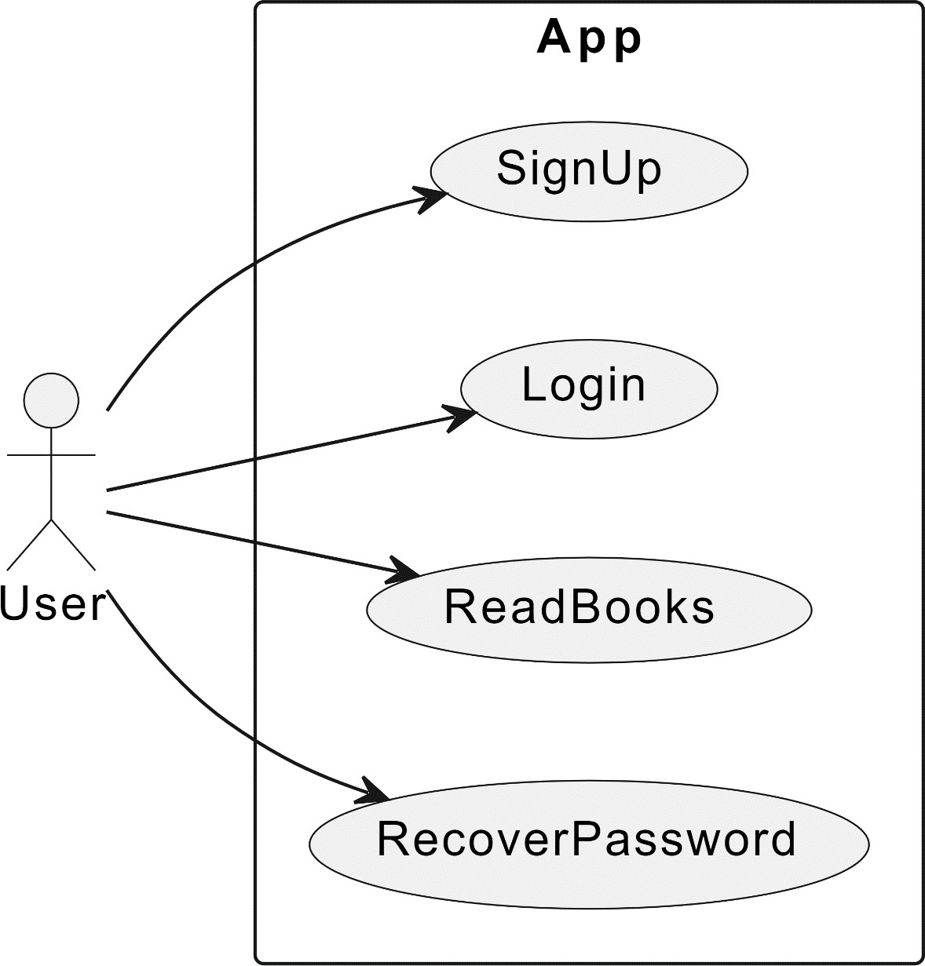
Fig. 3.1 Figure name

Table 1: Performance analysis
Name of metric | Method 1 | Method 2
Metric 1
Metric 2

CHAPTER – 4

SYSTEM ANALYSIS

Thisprojectfocusesonasecurepasswordrecoverymechanismtailoredforanonlinebookreadingplatform.Theprimaryobjectivesaretoensurethattherecoveryprocessis secure, user-friendly, and resistant to common attack vectors. By employing advanced security technologies and methodologies, the proposed mechanism aims to safeguard user accounts from unauthorized access while maintaining a seamless user experience. Implementing a secure password recovery mechanism will provide multiple benefits, including enhanced user trust, improved account security, and amore resilient platform against potential security threats. This initiative underscores our commitment to protecting user data and ensuring a safe and enjoyable reading experience for all users.

CHAPTER – 5

SYSTEM ANALYSIS

Thisprojectfocusesonasecurepasswordrecoverymechanismtailoredforanonlinebookreadingplatform.Theprimaryobjectivesaretoensurethattherecoveryprocessis secure, user-friendly, and resistant to common attack vectors. By employing advanced security technologies and methodologies, the proposed mechanism aims to safeguard user accounts from unauthorized access while maintaining a seamless user experience. Implementing a secure password recovery mechanism will provide multiple benefits, including enhanced user trust, improved account security, and amore resilient platform against potential security threats. This initiative underscores our commitment to protecting user data and ensuring a safe and enjoyable reading experience for all users.

CHAPTER – 6

SYSTEM ANALYSIS

Thisprojectfocusesonasecurepasswordrecoverymechanismtailoredforanonlinebookreadingplatform.Theprimaryobjectivesaretoensurethattherecoveryprocessis secure, user-friendly, and resistant to common attack vectors. By employing advanced security technologies and methodologies, the proposed mechanism aims to safeguard user accounts from unauthorized access while maintaining a seamless user experience. Implementing a secure password recovery mechanism will provide multiple benefits, including enhanced user trust, improved account security, and amore resilient platform against potential security threats. This initiative underscores our commitment to protecting user data and ensuring a safe and enjoyable reading experience for all users.

References
- C. M. Frenz, "Improving Organizational Password Policy Compliance via Open Source Tools," in 2011 IEEE World Congress on Services, USA, 2011.
- Y.Miller.PasswordRecovery.20thOctober2002.

- F. A. Maqbali and C. J. Mitchell, "Email-based Password Recovery - Risking or Rescuing Users?," in 2018 International Carnahan Conference on Security Technology (ICCST), Canada, 2018.
- 2012 linkedin breach just got a lot worse: 117 million new logins for sale (Last checked April 2018).
- Furnell, S.: A comparison of website user authentication mechanisms. Computer Fraud & Security 2007(9), 5–9 (2007).
- Barton,B.F.,Barton,M.S.:User-friendlypasswordmethodsforcomputer-mediated information systems. Comput. Secur. 3(3), 186–195 (1984).
- Reeder, R., Schechter, S.: When the password doesn’t work:Secondary authentication for websites. IEEE Security & Privacy 9(2), 43–49 (2011).
- Garfinkel,S.L.:Email-basedidentificationandauthentication:Analternativetopki? IEEE security & privacy 99(6), 20–26 (2003).
- MD5,Wikipedia,2024.[Online].Available:https://en.wikipedia.org/wiki/MD5.

